DEFECT REPORT
Automation Exercise
Defect ID | DF_ID_01
Module | User Sign Up
Headline | Signup password field accepts any value with no minimum length or complexity rule enforced
Test type | Negative type
Description | On the 'Enter Account Information' page of the signup flow, the Password field does not enforce any password rule. The application accepts weak passwords — including a single character, a short numeric-only string, or any arbitrary text — without any client-side or server-side validation. This allows user accounts to be created with insecure, easily guessable passwords, which is a data quality and security concern.
Test Data | Password used: “3456789886554321113245688978…." (numeric only, no complexity, no minimum-length rejection)
Expected Result | Password should follow defined complexity requirements, with appropriate validation feedback
Actual Result | The application accepts the weak password with no validation error of any kind and successfully creates the account ('ACCOUNT CREATED!' message is displayed).
Severity | Medium
Priority | High
Status | New/open
Attachment | screenshot_DEF_AE_001.png — screenshot of the account created successfully with a weak password (see attached image below)

Attachment
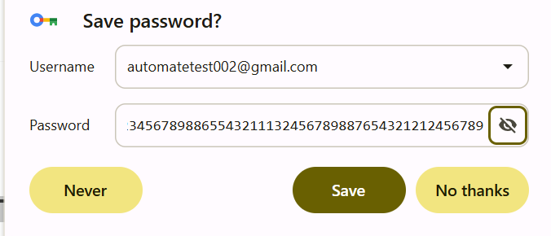
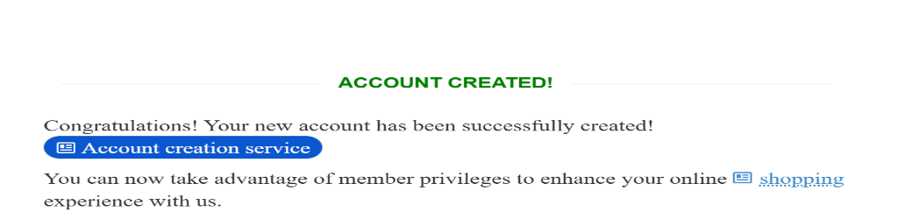
Defect ID | DF_ID_02
Module | User Sign Up
Headline | Mobile number field accepts alphabets and special characters without displaying validation error during account registration
Test type | Negative type
Description | On the 'Enter Account Information' page of the signup flow, the Mobile number field accepts alphabets and special characters. The application accepts weak mobile number including a single character, only string, or any special characters without any client-side or server-side validation
Test Data | Mobile number used: “a9987654321@#!hyfrwsqs”
Expected Result | Only valid numeric mobile numbers should be accepted
Actual Result | The application accepts the mobile number with single character or alphabets or special character and successfully creates the account ('ACCOUNT CREATED!' message is displayed).
Severity | Medium
Priority | High
Status | New/open
Attachment | screenshot_DEF_AE_002.png — screenshot of the account created successfully with a invalid mobile number (see attached image below)

Attachment


